PHOTO BOOTH – PRINTER
Order # ________ Client Last Name: ___________ Packed By: __________ Today’s Date: _____
- SOFTWARE UPDATES

Checked for Apple Software Updates (Install if needed)
Checked for SimpleBooth Software Updates (Install if needed)

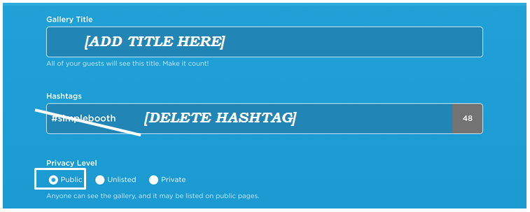
- GALLERY

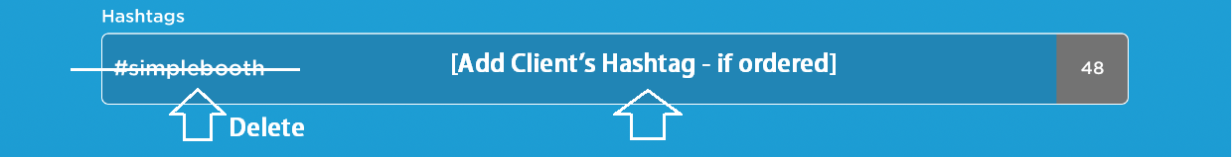
3. HASHTAGS
See Order Form: “HASHTAG”

4. PRIVACY & CONFIRM GALLERY

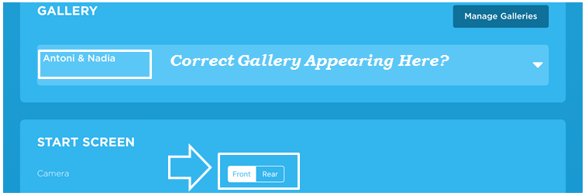

5. DESIGN / LAYOUT
See Order Form: “PHOTO STRIP LAYOUT”: Select photo layout as requested

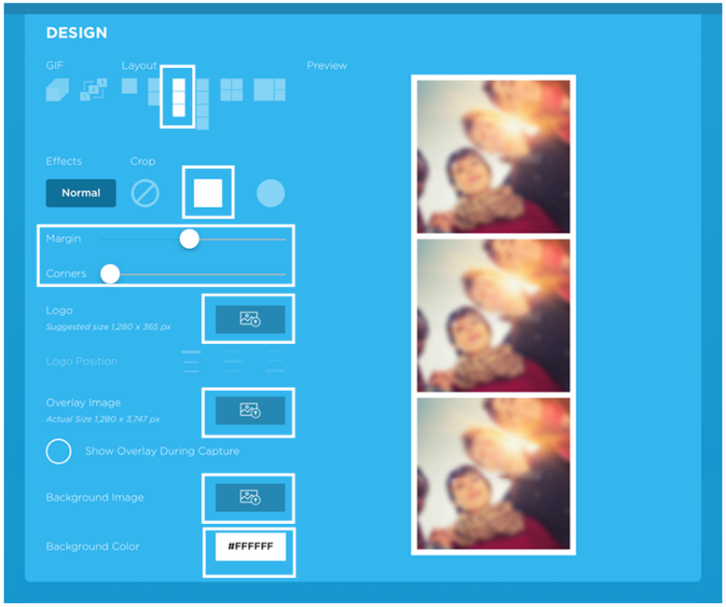
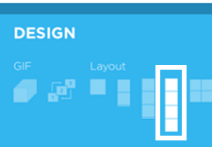
1 Photo

3 Photos

4 Photos
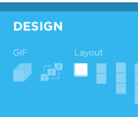

If 1 Photo Layout selected,
immediately get 100 sheets of UNPERFORATED photo paper.
All other orders get perforated paper, which you will do at the end.

6. SHAPE & MARGIN

7. LOGO
Review Order Form: “DESIGN FOR PHOTO STRIPS”. Fill out A or B below.
A) NO DESIGN

Send message to Admin Team: [Order #]: No Design

Delete any prior logos from app. Screen should look like this:

B) ADD DESIGN

Upload design.

Choose Position

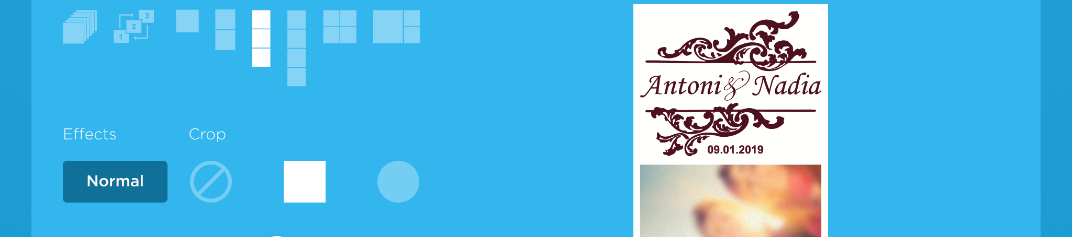
Screenshot & send to Admin:
[Order #] [Screenshot Image]

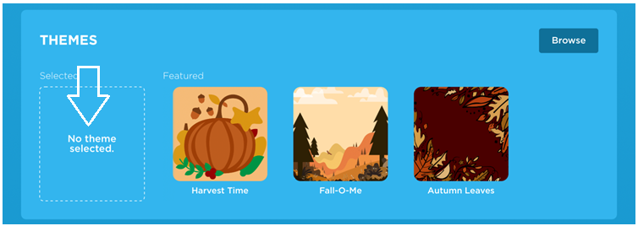
8. THEME
No Theme

9. SEND OPTIONS


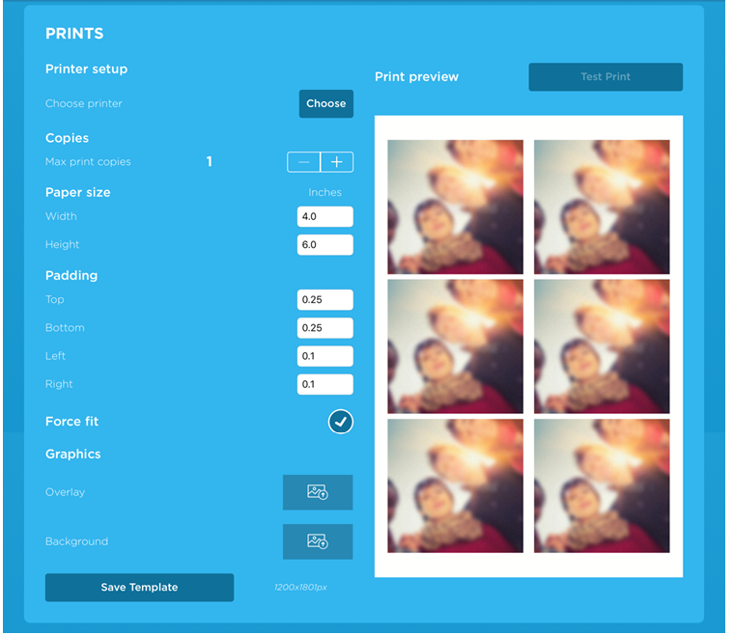
10. PRINT OPTIONS
Connect
Printer

11. EMAIL TEMPLATE
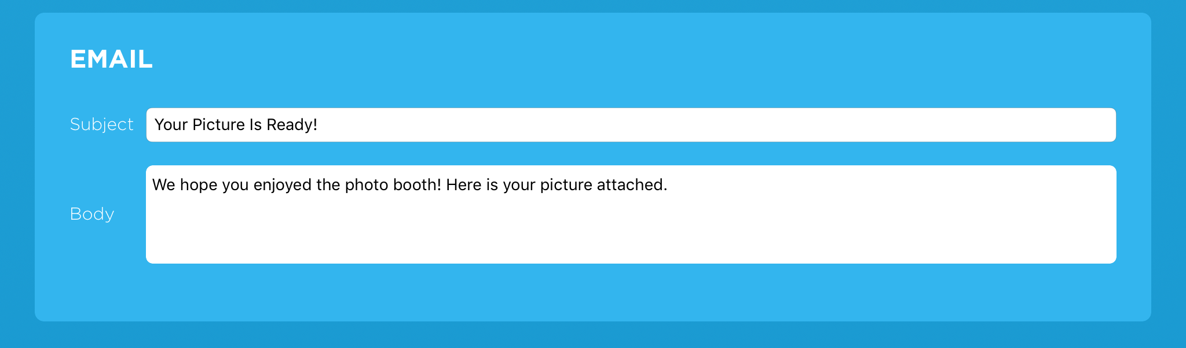

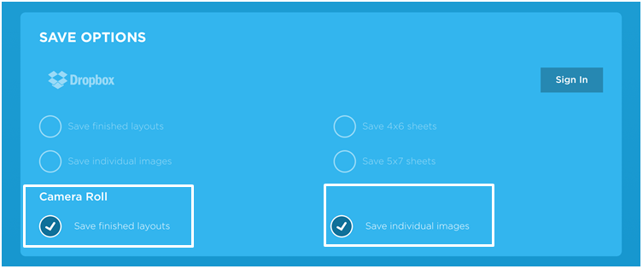
12. SAVE OPTIONS

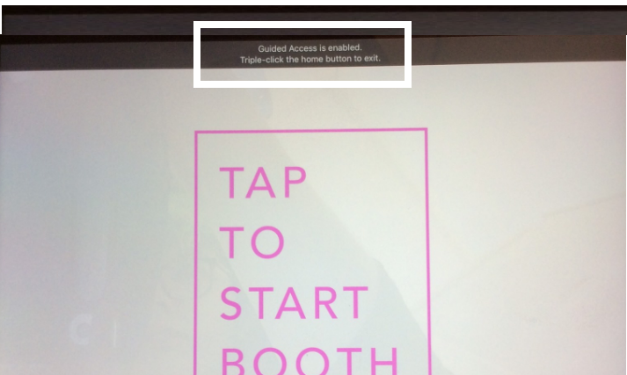
13. START BOOTH MODE

Guided Access
Enabled

14. TEST PHOTOS
Connect to WiFi (Netgear01). Take a sample photo using the app. Test all sharing options:
TEXT (305-697-8193)
EMAIL (info@rentmywedding.com)
PRINT (Staple photo strip to this form )

15. PHYSICAL INSPECTION
A) MONITOR
 Camera Lined Up with Hole
 ON / OFF Stickers Intact
 Tape on iPad is Secure
 Fabric Back Attached
 Power Cord Attached to iPad
 Monitor in Good Condition (no missing pieces, major scratches, etc.)

B) FLASH
 New Batteries Added
 Flash Attached to Clamp (or securely glued onto monitor)
 Tested Flash - Working

C) PRINTER
 Printer in Good Condition (no missing pieces, major scratches, etc.)
 New Ink Added
 Sign “Place Paper Here” Intact (on paper tray)
 Sticker “Power” Intact (top of printer)
 Sticker “Do Not Touch” Intact (top of printer)
 Sticker with Serial Number Intact (bottom of printer)
 Power Cord Intact (2 pieces connected)
16. PACK ORDER
WHEN FINISHED:
- Place monitor & printer (in shipping cases) on inventory shelf. Stack them on top of each other.
- Tape this form onto shipping cases.
**Only stack cases on top of each other if they are for the same order.**
Box 1:
 Monitor
 Clamp + Flash
 Wall Charger Block
 15 Props (Assorted)
 Setup Instructions
 Sign: “Charge Photo Booth Before Event”

Box 2:
      Printer (with new ink installed)
      Power Cord for Printer
      100 Sheets Photo Paper
--> Always perforated paper – unless you already grabbed non-perforated paper for this order during setup above (1 photo layout)

