PHOTO BOOTH – DIGITAL
Order # ________ Client Last Name: ___________ Packed By: __________ Today’s Date: _____
- SOFTWARE UPDATES

Checked for Apple Software Updates (Install if needed)
Checked for SimpleBooth Software Updates (Install if needed)

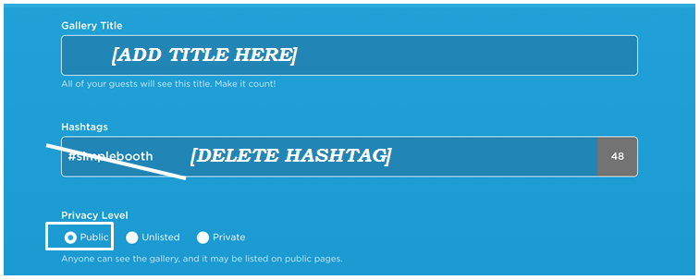
- GALLERY

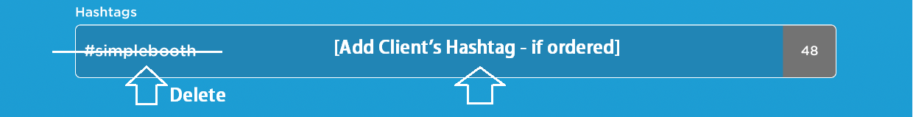
3. HASHTAGS
See Order Form: “HASHTAG”

4. PRIVACY & CONFIRM GALLERY

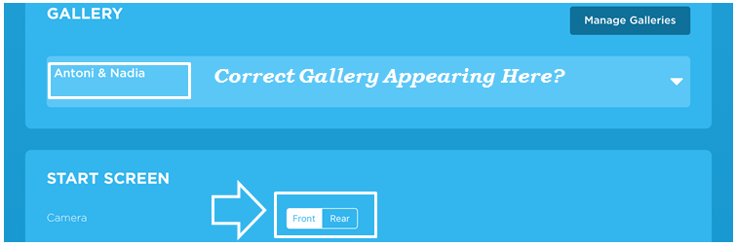

5. DESIGN / LAYOUT
See Order Form: “PRINTER OR DIGITAL” and “PHOTO STRIP LAYOUT”
--If DIGITAL: Select photo layout as requested on order
--If ANIMATED GIF: Select “GIF” on app. Ignore client’s photo layout request.
1 Photo

3 Photos

4 Photos

Animated GIF
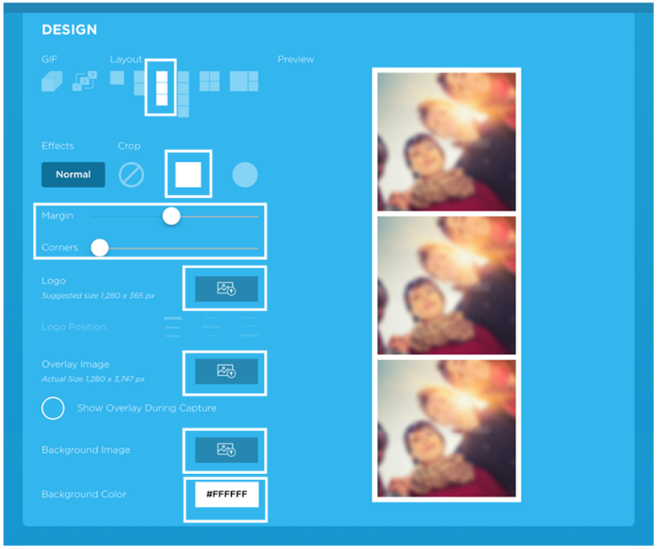
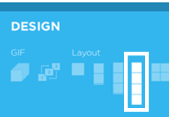
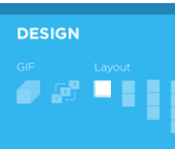
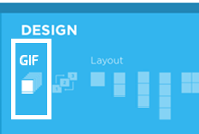

6. SHAPE & MARGIN

7. LOGO
Review Order Form: “DESIGN FOR PHOTO STRIPS”. Fill out A or B below.
A) NO DESIGN

Send message to Admin Team: [Order #]: No Design

Delete any prior logos from app. Screen should look like this:

B) ADD DESIGN

Upload design.

Choose Position

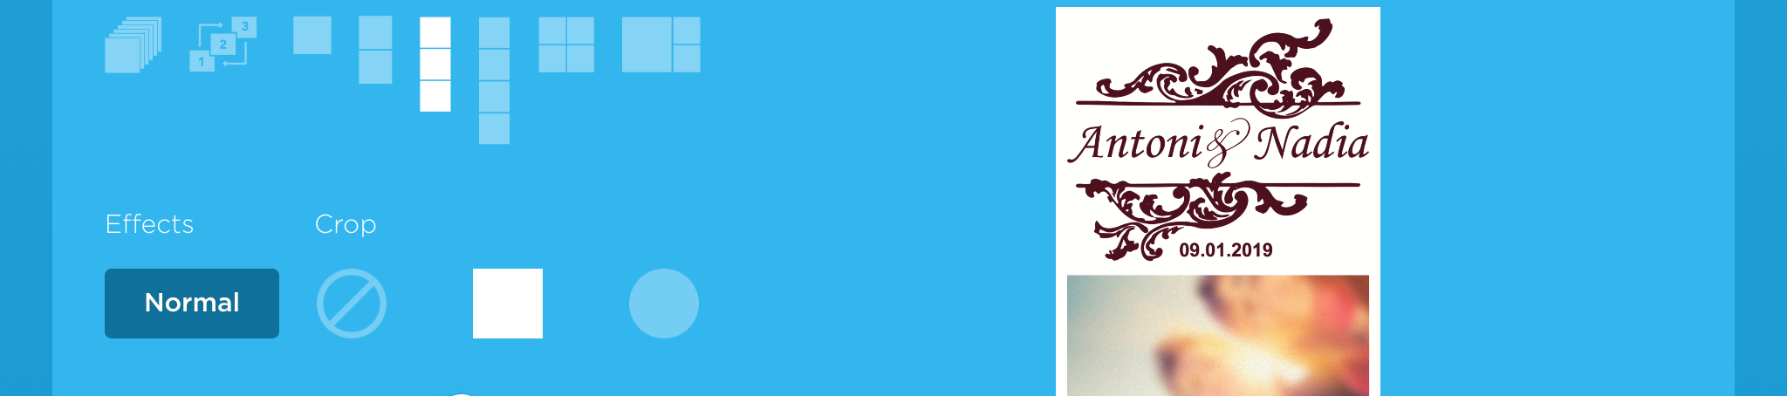
Screenshot & send to Admin:
[Order #] [Screenshot Image]

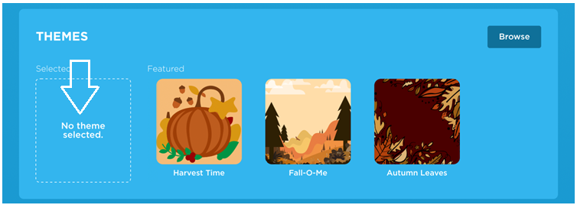
8. THEME
No Theme

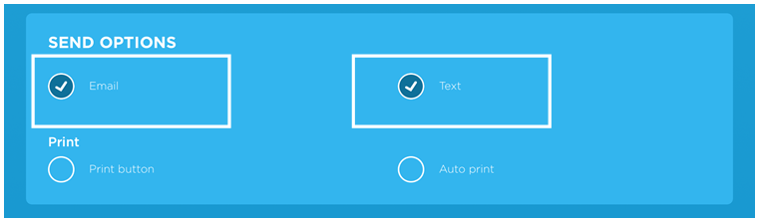
5. SEND OPTIONS

6. EMAIL TEMPLATE
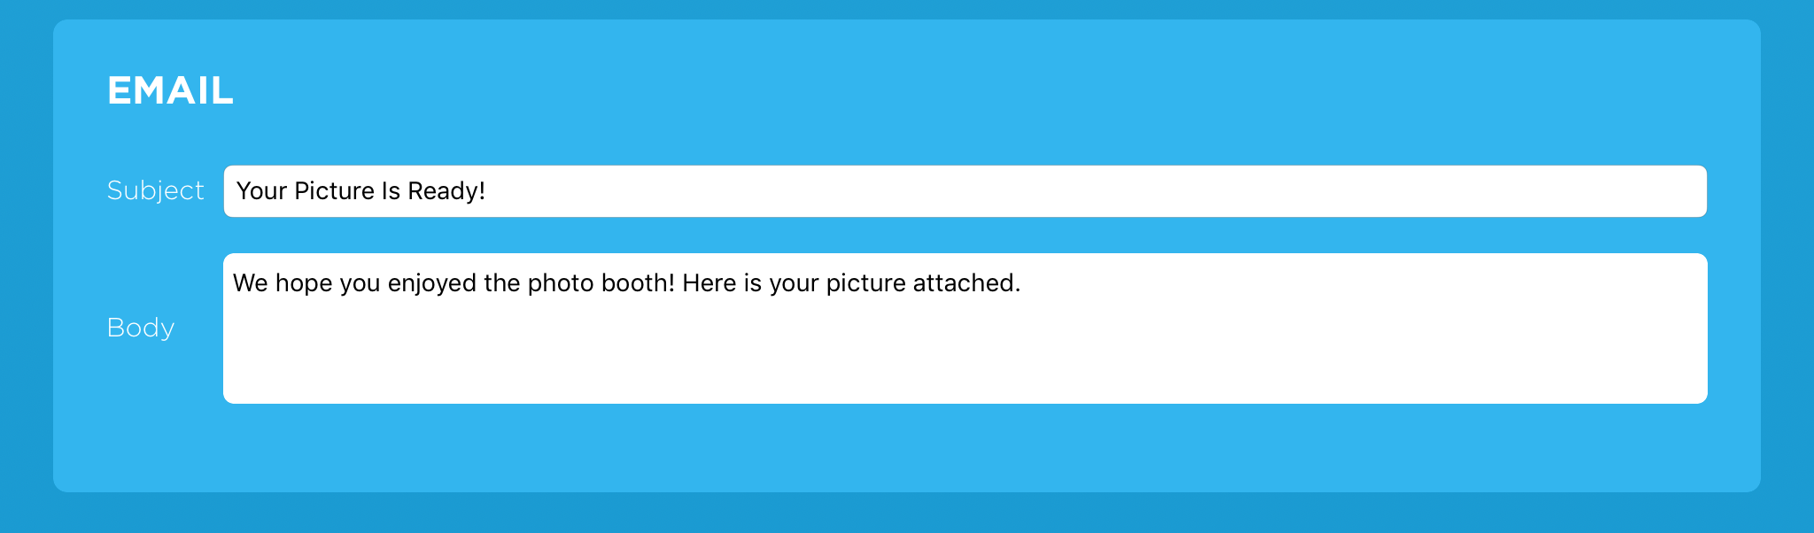

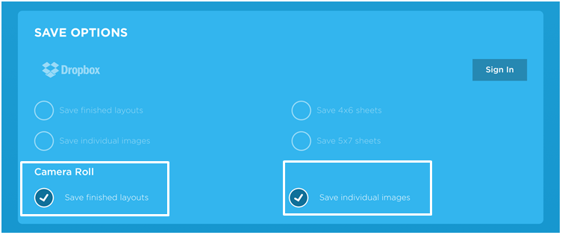
7. SAVE OPTIONS

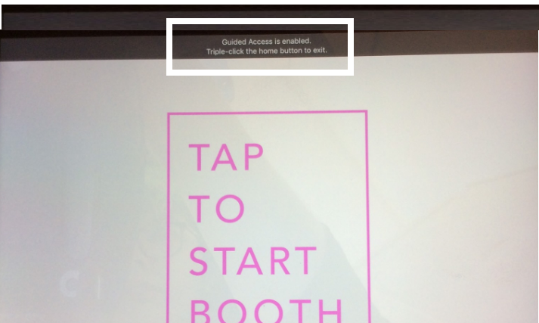
8. START BOOTH MODE

Guided Access
Enabled

9. TEST PHOTOS
Connect to WiFi (Netgear01). Take a sample photo using the app & confirm all sharing options work:

TEXT (305-697-8193)
EMAIL (info@rentmywedding.com)

10. PHYSICAL INSPECTION
A) MONITOR
 Camera Lined Up with Hole
WHEN FINISHED:
- Place monitor (in shipping case) on inventory shelf.
- Tape this form onto shipping case.
**Do not stack cases on top of each other (unless they are all part of the same order).
**Can place monitors vertically on shelf to maximize space.
 ON / OFF Stickers Intact
 Tape on iPad is Secure
 Fabric Back Attached
 Power Cord Attached to iPad

B) FLASH
 New Batteries Added
 Flash Attached to Clamp (or securely glued onto monitor)
 Tested Flash - Working

11. PACK ORDER
 Monitor
 Clamp + Flash
 Wall Charger Block
 15 Props (Assorted)
 Setup Instructions
 Sign: “Charge Photo Booth Before Event”

